|  |
| --- |
| **History – Cold War in Asia** |

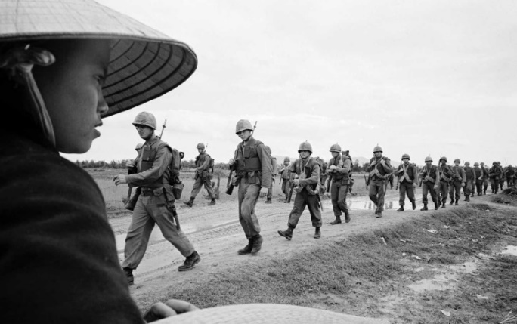

**Welcome to History!** In preparation for September we would like you to begin getting to know about the Cold War in Asia and some of the key events and concepts that are part of our new and exciting course. In order to do this we would like you to complete the series of activities below. You will need to bring this work to lessons as we will be drawing from this knowledge in our classroom discussions in the few first weeks of the new term.

|  |
| --- |
| **Tasks** |
| 1. **The Second World War in Asia**  * Read this summary on the end of WW2 (specifically 1943 Europe- consequences of the atom bomb) and make notes, consider: What happened? How might this impact the Cold War?   [World War Two: An Overview - World War Two and the Holocaust - KS3 History - homework help for year 7, 8 and 9. - BBC Bitesize](https://www.bbc.co.uk/bitesize/topics/zk94jxs/articles/z6vff82#zb7jjsg)   * Read this summary of the start of the Cold War up to ‘Truman Doctrine and Marshall Plan’ and make notes consider: what is it about? What happened? When did it happen?   [The start of the Cold War 1945-55 - The Cold War - KS3 History - homework help for year 7, 8 and 9. - BBC Bitesize](https://www.bbc.co.uk/bitesize/topics/z8k9q6f/articles/z77cg7h#z8n3vwx)   1. **Individuals we need to get to know**   Use p. 4-6 of the transition reading document to create a fact-file page of the key individuals on topic 1 of the Cold War in Asia topic:   * Josef Stalin * Harry S. Truman * Mao Zedong   You could add to this with further research if you wanted to find out more.   1. **Choose one of these tasks:**  * Read through the information on the Vietnam War on divide your notes into causes, events and consequences.   [Background to the Vietnam War - The Vietnam War - AQA - GCSE History Revision - AQA - BBC Bitesize](https://www.bbc.co.uk/bitesize/guides/zyh9mnb/revision/1)  [Background to the Vietnam War - The Vietnam War - AQA - GCSE History Revision - AQA - BBC Bitesize](https://www.bbc.co.uk/bitesize/guides/zyh9mnb/revision/1)   * Read through the information on the Korean War on and divide your notes into causes, events, and consequences.   [What caused the Korean War? - BBC Bitesize](https://www.bbc.co.uk/bitesize/topics/z9kj4qt/articles/zkfnrmn#z8yscxs)   * Read through this section on China, make notes on the government of China. Consider: causes, events and consequences. Try to write 3 bullet points for each section.   [The Chinese Civil War: Causes, Rise Of Mao Zedong & Republic of China | HistoryExtra](https://www.historyextra.com/period/20th-century/chinese-civil-war-china-chiang-kai-shek-mao-zedong-communism/)   1. **Western powers in Asia**  * Watch <https://www.youtube.com/watch?v=Y2IcmLkuhG0>. Make sure you have key dates of events, countries involved, outcome for the Korean and Vietnam war. |
| **Extra reading** |
| **Inspired? If you can’t wait until September to find out more you could:**   * Go back over your Cold War GCSE course so you’re happy with the causes of the Cold War particularly * <https://www.iwm.org.uk/history/a-quick-guide-to-japans-role-in-the-second-world-war> * <https://www.iwm.org.uk/history/britains-war-in-the-far-east-during-the-second-world-war> * The Cold War by Odd Arne Westad can be accessed on Google Books (doesn’t have complete copy though) <https://books.google.co.uk/books?id=4fotDwAAQBAJ&printsec=frontcover&dq=the+cold+war+odd+arne+westad&hl=en&sa=X&ved=0ahUKEwj3o-68gejpAhVRaRUIHYRVCAAQ6wEITDAE#v=onepage&q&f=true> * In Our Time Podcast: Karl Marx <https://www.bbc.co.uk/programmes/p003k9jg> * In Our Time: Sino Japanese War <https://www.bbc.co.uk/programmes/b042ldyq> * Witness History Podcast on The Beginning of the Korean War: <https://www.bbc.co.uk/programmes/w3cswsn8> * Witness History Podcast on The Korean War: <https://www.bbc.co.uk/programmes/p0086hv0> * BBC Witness History Podcast on The Vietnam War: Surviving the ‘Christmas Bombing Campaign: <https://www.bbc.co.uk/programmes/w3csyww8> * The BBC have done a series of documentaries on the aftermath of the Cold War, here is one on Indonesia: <https://www.bbc.co.uk/programmes/w3cszbfg> * BBC Race Across the World S1 Ep5, particularly at 48 mins <https://www.bbc.co.uk/programmes/m0003wy2> visiting Choeung Ek killing fields of Cambodia. * If you’re looking for something more historically rigorous you should refer to the read/watch/listen list. There are some wonderful documentaries, podcasts and books on there.   [Read watch listen - Cold War in Asia.pptx](https://littleheath.sharepoint.com/:p:/s/HistoryPoliticsDept/EeT7IZJq35VWgkrF6G9rGkQB0s2oCUbp24I7Xdxqjm_Hng?e=2Geqi7)  If you need any help or have any questions about this preparation work you can contact us by email:  Miss Elsdon – [kelsdon@littleheath.org.uk](mailto:kelsdon@littleheath.org.uk) |

