Data Analytics

We are asking all students to complete some Independent Preparatory Work over the summer, before they join Year 12 in September. You will need to bring this work to lessons as the content will be assessed through introductory assessments which will be completed within the few first weeks of the new term.
Tasks
Learn about Excel from the tutorials here:

https://www.w3schools.com/excel/index.php

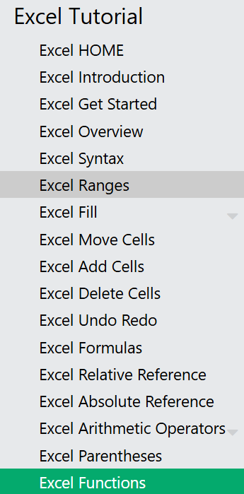

Extra reading
you can extend your learning by doing more lessons.
