FRENCH

We are asking all students to complete some Independent Preparatory Work over the summer, before they join Year 12 in September. You will need to bring this work to lessons as the content will be assessed through introductory assessments which will be completed within the few first weeks of the new term.
Tasks
- Please work through the grammar workbook, completing as much as you can. For topics not covered at GCSE (e.g the subjunctive or pluperfect tense) feel free to leave these out as these topics will be taught during the year 12 course. This version is a PDF, so please print it before starting to work through the exercises. If you would prefer me to print it for you, please come and see me or e mail sleach@littleheath.org.uk and I can do that for you.

- Please buy yourself a “livre de poche” version of the book by Joseph Joffo – “un sac de billes”. You can buy this on amazon. It is really important that you buy the “livre de poche” version (see below). It would be good to buy an English version too (“A bag of marbles”) and start to read this to get the gist of the story.

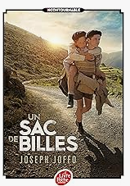

Extra reading (see above)

