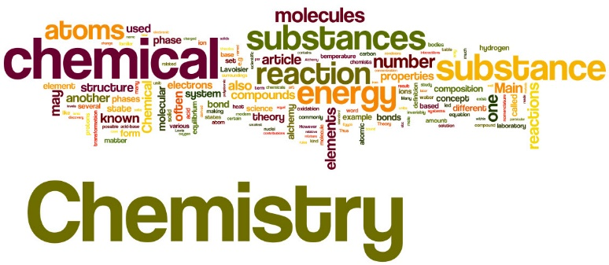**Chemistry Glossary Task**

**(Transition 2025)**

When you research these terms it is important that you give a scientific/chemical definition not an English language definition (sometimes they are the same, sometimes they are not!).

These are some of the key terms for the first chapter of A level chemistry **‘Elements of life’**. There are 10 chapters in the course (5 in Y1 and 5 in Y2). Many of these terms should be familiar to you from GCSE. Some need a definition, some just a symbol and others just need you to show you understand what the term means.

For example:

* abundance – find a definition
* carbonate ion – give the chemical symbol and charge.
* balanced equation – give an example

I would also like you to highlight any term that you do not understand at all. This way when you have completed the chapter ‘Elements of life’ you can review this glossary and hopefully see how your understanding has progressed.

|  |  |
| --- | --- |
| **Term** | **Definition/Symbol/Example to show your understanding.** |
| absorption |  |
| abundance |  |
| acid |  |
| alkali |  |
| alloy |  |
| ammonium ion |  |
| anion |  |
| aqueous |  |
| atom |  |
| atom economy |  |
| attraction |  |
| Avogadro's constant |  |
| balanced equation |  |
| base |  |
| boiling point |  |
| bond |  |
| by-product |  |
| carbonate ion |  |
| cation |  |
| centimetre cubed |  |
| charge |  |
| compound |  |
| concentration |  |
| co-product |  |
| covalent bond |  |
| Dative (covalent bond) |  |
| decimetre cubed |  |
| delocalised |  |
| density |  |
| electron |  |
| electronic configuration |  |
| electrostatic attraction |  |
| element |  |
| emission |  |
| empirical formula |  |
| energy |  |
| energy level |  |
| enthaply |  |
| equation |  |
| fission |  |
| formula |  |
| formulae |  |
| frequency |  |
| fusion |  |
| gas |  |
| group |  |
| hydroxide ion |  |
| intensity |  |
| intermolecular |  |
| intermolecular force |  |
| intramolecular |  |
| ion |  |
| ionic bond |  |
| ionic equation |  |
| ionisation |  |
| isotope |  |
| lewis diagram |  |
| linear |  |
| liquid |  |
| lone pair (of electrons) |  |
| mass |  |
| mass spectrometry |  |
| melting point |  |
| metallic bond |  |
| mixture |  |
| mole |  |
| molar |  |
| molecule |  |
| neutralisation |  |
| neutron |  |
| nitrate ion |  |
| nucleus |  |
| octahedral |  |
| orbital |  |
| oxidation |  |
| oxonium ion |  |
| particle |  |
| percentage yield |  |
| period |  |
| periodic table |  |
| periodicity |  |
| photon |  |
| planar |  |
| Planck's constant |  |
| plasma |  |
| polar |  |
| polarisation |  |
| precipitate |  |
| probability |  |
| proton |  |
| quanta |  |
| radius |  |
| reactivity |  |
| reduction |  |
| relative atomic mass |  |
| relative formula mass |  |
| relative molecular mass |  |
| repulsion |  |
| salt |  |
| shell |  |
| solid |  |
| solubility |  |
| solute |  |
| solution |  |
| solvent |  |
| spectator ion |  |
| spectra |  |
| speed |  |
| spin |  |
| standard solution |  |
| stoichiometry |  |
| sub-shell |  |
| sulfate ion |  |
| sum |  |
| tetrahedral |  |
| thermal decomposition |  |
| titration |  |
| titre |  |
| trigonal planar |  |
| volume |  |
| volumetric flask |  |
| VSEPR |  |
| waste |  |
| wave |  |