COLLEGE OPEN EVENTS FROM SPETEMBER 2025
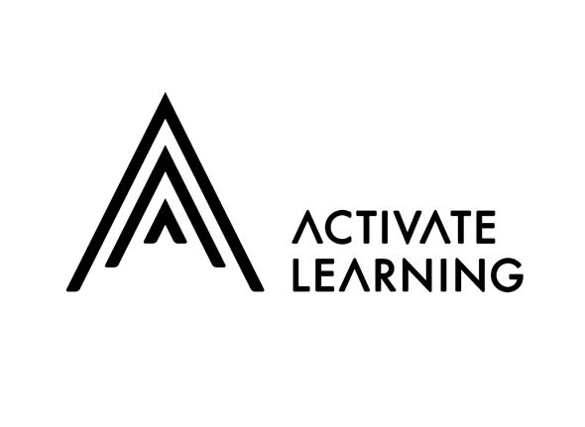
BRACKNELL AND WOKINGHAM COLLEGE
18th October, 9:30am - 12pm Bracknell and Wokingham College October Open Event - Bracknell and Wokingham College
19th November, 4:30pm - 7pm Bracknell and Wokingham College November Open Event - Bracknell and Wokingham College

MERRIST WOOD COLLEGE
15th October, 4:30pm - 7pm Merrist Wood College October Open Event - Merrist Wood College and University Centre
8th November, 9:30am - 12pm Merrist Wood November Open Event - Merrist Wood College and University Centre

READING COLLEGE
15th October, 4:30pm - 7pm Reading College October Open Event
8th November, 9:30am - 12pm Reading College November Open Event - Reading College


BCA COLLEGE
4TH October 2025, 15th November 2025, 18th April 2026 Events Archive - Berkshire College of Agriculture - BCA

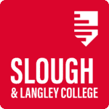
SLOUGH & LANGLEY COLLEGE
5th November, 16:00 - 18:30 pm Slough & Langley College November Open Evening - 5th November 2025 - Windsor Forest College
25th March 2026, 16:00 - 18:30 pm Slough & Langley College March Open Evening - 25th March 2026 - Windsor Forest College
24th June 2026, 16:00 - 18:30 pm Slough & Langley College June Open Evening - 24th June 2026 - Windsor Forest College

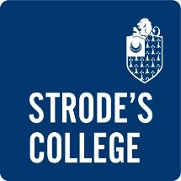
STRODE’S COLLEGE
23rd October, 16:30 - 19:00 pm Strode's College October Open Evening - 23rd October 2025 - Strode's College
12th February 2026, 16:30 - 19:00 pm Strode's College February Open Evening - 12th February 2026 - Strode's College
2nd July 2026, 16:30 - 19:00 pm Strode's College February Open Evening - 2nd July 2026 - Strode's College

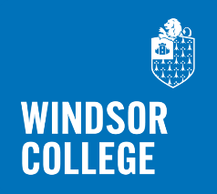
WINDSOR COLLEGE
14th October 2025, 16:30 - 19:00 pm Windsor College October Open Evening - 14th October 2025 - Windsor College
24th February 2026, 16:30 - 19:00 pm Windsor College February Open Evening - 24th February 2026 - Windsor College
30th June 2026, 16:30 - 19:00 pm Windsor College June Open Evening - 30th June 2026 - Windsor College

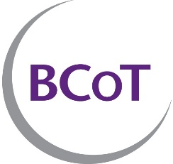
BASINGSTOKE COLLEGE OF TECHNOLOGY
13th October, 16:30pm Open Event: 13 October 2025 Tickets, Mon 13 Oct 2025 at 16:30 | Eventbrite
22nd November, 10:00am Open Day: 22 November 2025 Tickets, Sat 22 Nov 2025 at 10:00 | Eventbrite

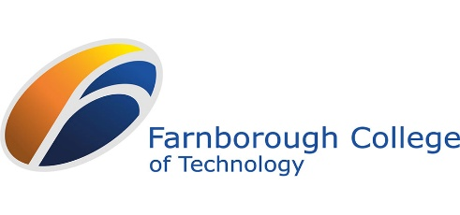
FARNBOROUGH COLLEGE OF TECHNOLOGY
14th October, 4:00pm - 7:30pm Year 10 and 11s College Open Event – 14th October - Farnborough College of Technology
15th October, 4:00pm - 7:30pm Year 10 and 11s College Open Event – 15th October - Farnborough College of Technology
16th October, 4:00pm - 6:30pm Year 10 and 11s Aldershot Construction College Open Day – 16 October - Farnborough College of Technology
19th November, 4:00pm - 7:30pm Year 10 and 11s College Open Event – 19th November - Farnborough College of Technology
20th November, 4:00pm - 6:30pm Year 10 and 11s Aldershot Construction College Open Event – 20th November - Farnborough College of Technology
11th February 2026, 4:00pm - 7:30pm Year 10 and 11s College Open Event – 11th February - Farnborough College of Technology
12th February 2026, 4:00pm - 6:30pm Year 10 and 11s Aldershot Construction College Open Event – 12th February - Farnborough College of Technology

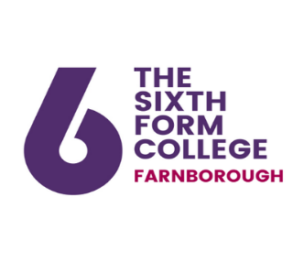
FARNBOROUGH SIXTH FORM COLLEGE
The Sixth Form College Farnborough
You can book your tickets here:
Tuesday 30 September 2025
Wednesday 1 October 2025
Thursday 2 October 2025


HENLY COLLEGE
30th September, 5:30pm and 8:00pm Upcoming Events - The Henley College
16th October, 5:30pm and 8:00pm Upcoming Events - The Henley College

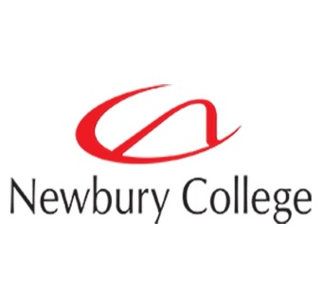
NEWBURY COLLEGE
We are working on our next set of events at Newbury College, but our Virtual Open Day is every day!
Discover Newbury College! Open Events

