Dear Students, Parents and all customers,
Upcoming Tariff Changes – September 2026
At Culinera, we are proud to serve over 85,000 students each day, providing fresh, high-quality food across our schools.
We use great ingredients to create a wide range of options that are designed to suit different tastes and budgets. We offer a broad menu with items starting from as little as 90p, alongside regular promotions, themed menus, and meal deals to ensure strong value for money.
Our food development team continues to introduce new recipes that reflect current food trends while keeping everyday affordability in mind. Where available, we also run after-school offers with discounted items, helping to reduce food waste while giving students even better value.
Over recent months, there have been a number of significant changes that are increasing the cost of delivering catering services in schools. These are largely driven by Government policy and wider economic pressures and are having a direct impact on the cost of operating our service.
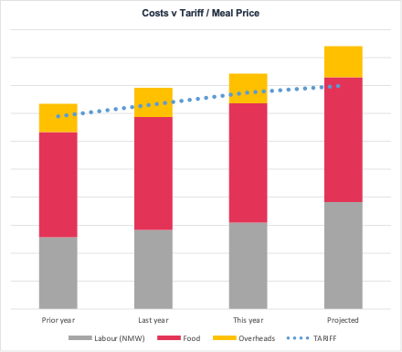
Rising food costs and supplier impacts – We are proud to work with a wide network of suppliers and to support local producers wherever possible. However, ongoing global events, including conflict in the Middle East and Europe, have driven up costs across the food and supply chain. While we have worked hard with our suppliers to minimise these increases, they have resulted in higher costs across nearly all products and ingredients.
Supporting our teams and talent – In April, the Government introduced a 4.2% increase to the National Minimum Wage, a positive step to support our teams with the cost of living. In addition, we have increased pay for our onsite supervisors and managers to ensure we continue to attract and retain high-quality people. This reflects our commitment to the teams delivering your food every day. To ensure we can continue to maintain the quality, choice, and service standards you expect, we will be making a small adjustment to our menu pricing from September 2026.
A select few food items will increase by 5p, with some increasing by 10p. This represents an average increase of 2.2%, which is significantly lower than the underlying cost increases we are experiencing. This adjustment helps to cover only part of these additional costs, and we continue to focus on operating efficiently and keeping prices as low as possible.
Thank you for your continued support. Your feedback is important to us, and we encourage you to share your thoughts using the QR code below or by visiting: https://feedback.culinera.co.uk
We look forward to continuing to serve you with food that is fresh, enjoyable, and great value.

  Thomas Pass  Founder  Culinera | Leave Culinera feedback!  Either scan the below QR or visit https://feedback.culinera.co.uk  

