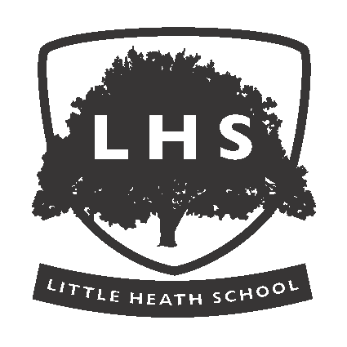LITTLE HEATH SCHOOL
Little Heath Road, Tilehurst
Reading, Berkshire, RG31 5TY
Headteacher: Mr D J Ramsden

HEAD OF MUSIC

Required from September 2025
TLR2(c) £8,276.00 p.a.

We are seeking to appoint an inspirational and enthusiastic teacher of Music to lead our successful and ambitious department. Little Heath has a long-standing tradition of music and performance being at the heart of the school. GCSE Music is a popular course at Key Stage 4. In Key Stage 5, we offer traditional A Level courses in Music and Music Technology. Our curriculum plans for Key Stage 3 involve innovative and exciting schemes of work which aim to build key skills for all students as a platform for further study and enjoyment. The Music Department are passionate about extra-curricular provision and are keen to showcase the talents of our students in the variety of musical events that we organise throughout the academic year and the sell-out musicals that we put on every two years. These events are held in our new purpose-built multifunctioning performance space in the new building. The department also boasts its own purpose-built suite, including practice rooms, teaching rooms and a recording studio.

The person we are seeking will:
- be a successful teacher across the age and ability range;
- have strong leadership, management and communication skills;
- be passionate about teaching Music, being able to bring energy, enthusiasm and new ideas to the department;
- being able to teach Music Technology would be desirable;
- have experience of raising standards and setting high expectations for the achievement of all students, in Music and Music Technology, particularly at Key Stage 5;
- have a high level of musical proficiency in at least one or two instruments;
- be keen to lead and support extra-curricular ensembles;
- have experience of collaboration within Music, Art and Drama;
- be able to develop challenging and exciting programmes of study for gifted students in Music and Music Technology.

Little Heath School is a highly successful comprehensive school (1658 on roll, including 366 in the Sixth Form) situated in a pleasant semi-rural setting to the west of Reading, with good access to road and rail links. The school has recently benefited from a significant and transformational building project, opening a new £15 million main block in spring 2021. New staff will also be given their own laptop to work on and their own classroom base when they join.

As a school, we pride ourselves on our Continuing Professional Development Programme, which supports teachers to continually improve their practice in innovative ways, collaborating with other members of staff.

This role has been identified as public facing in accordance with Part 7 of the Immigration Act 2016, and therefore the ability to converse at ease with pupils/members of the public and provide advice/instruction in accurate spoken English is essential for the post.

Little Heath School is committed to safeguarding children and promoting the welfare of children and young people; we expect all staff and volunteers to share this commitment. Little Heath School will ensure that all recruitment and selection practices reflect this commitment. All shortlisted candidates will be asked to complete a criminal records self-disclosure form and successful candidates will be subject to Disclosure and Barring Service (DBS) checks along with other relevant employment checks

For an application form and information pack please email recruitment@littleheath.org.uk . Please address supporting letter of application to the Headteacher. Closing date for the receipt of completed applications is 05th May 2025 We reserve the right to interview before this date if a suitable shortlist is obtained, so early application is encouraged.


