LITTLE HEATH SCHOOL
Relationships and Sex Education POLICY
Policy objectives

This policy covers our school’s approach to teaching Relationships and Sex Education (RSE). This draft document has been produced by Miss Waissen, Personal Development Lead, in line with the new statutory guidance from the Government. This policy will be adapted after consultation with parents and Governors and reviewed regularly.

We are required to teach RSE as part of statutory guidance set out by the Department of Education which states that from September 2020, all schools must deliver relationships education (in primary schools) and relationships and sex education (in secondary schools). Little Heath School have been delivering some content in line with the new statutory guidance since the academic year 2019-20 as we are an ‘Early Adopter School’.

We define ‘Relationships and Sex Education’ as learning about the emotional, social and physical aspects of growing up, relationships, sex, human sexuality and sexual health. Some aspects are taught in science, and others are taught as part of Personal, Social, Health and Economic education (PSHE). A comprehensive programme of RSE provides accurate information about the body, reproduction, sex, and sexual health.

Management of policy

School: This policy is implemented and managed by the Personal Development Lead (Miss Waissen) and Assistant Head (Mrs Coneley) in conjunction with the Headteacher.

Governing Body: The Governing Body has delegated the oversight, review and updating of this policy to its Behaviour, Welfare and Safety Committee. This policy will be reviewed annually.

Approval: Approved by the Behaviour, Welfare and Safety Committee of the Governing Body on XXXXXXXX

Next review due: XXXXXX 2021

Associated documents

Child Protection and Safeguarding Policy

Appendices

Appendix 1 - DfE statutory guidance on Relationships and Sex Education (RSE) and Health Education

What is the purpose of RSE?

The aim of RSE is to give young people the information they need to help them develop healthy, nurturing relationships of all kinds, not just intimate relationships. It enables them to know what a healthy relationship looks like and what makes a good friend, a good colleague and a successful marriage or other type of committed relationship. It also covers contraception, developing intimate relationships and resisting pressure to have sex. RSE gives children and young people essential skills for building positive, enjoyable, respectful and non-exploitative relationships and staying safe both on and offline. This will help pupils understand the positive effects that good relationships have on their mental wellbeing, identify when relationships are not right and understand how such situations can be managed.

Safeguarding

Teachers are aware that effective RSE, which brings an understanding of what is and what is not appropriate in a relationship, can lead to a disclosure of a child protection issue. In this instance, teachers will consult with the designated safeguarding lead (Mrs Cameron) and in her absence the deputy safeguarding person (Mrs Gonzalez) to ensure that this is dealt with swiftly and appropriately.

Visitors to the school who support the delivery of RSE will be accompanied by school staff at all times whilst on school site.

Inclusivity:

We ensure that our RSE curriculum is inclusive and meets the needs of our pupils, including those with special educational needs, through differentiation and ensuring that all teaching is sensitive and age appropriate in approach and content. Little Heath School also ensures RSE fosters gender equality and LGBTQ+ equality in accordance with the Equality Act, 2010 through challenging stereotypes and acknowledging LGBTQ+ relationships as well as heterosexual relationships.

What are the benefits of effective RSE?

- a positive ethos and environment for learning
- safeguarding pupils (Children Act 2004), promoting their emotional wellbeing, and improving their ability to achieve in school
- a better understanding of diversity and inclusion, a reduction in gender-based and homophobic prejudice, bullying and violence and an understanding of the difference between consenting and exploitative relationships
- helping pupils keep themselves safe from harm, both on and offline, enjoy their relationships and build confidence in accessing services if they need help and advice
- reducing early sexual activity, teenage conceptions, sexually transmitted infections, sexual exploitation and abuse, domestic violence and bullying

How is the RSE programme delivered?

Miss Waissen, Personal Development Lead, will lead the RSE programme in collaboration with Mrs Coneley, Assistant Head. The subject will be taught through P7/P8/P9 lessons by a team of teachers across a range of departments. This will be supplemented by RSE ‘Drop Down Days’ (days off timetable) in upper KS4 and KS5. All staff will teach from the same materials, and receive in-house training on the different topics they cover so that pupils receive high standards of specialist teaching across the school.

High quality resources will support our RSE provision and will be regularly reviewed to ensure that the curriculum is comprehensive and up to date.

Parental right of withdrawal:

In secondary education from September 2020:
- Parents will not be able to withdraw their child from any aspect of Relationships Education or Health Education.
- Parents will be able to withdraw their child (following discussion with the Head Teacher) from any or all aspects of Sex Education, other than those which are part of the science curriculum, up to and until three terms before the age of 16.
- After that point, the guidance states that ‘if the child wishes to receive sex education rather than be withdrawn, the school should make arrangements to provide the child with sex education during one of those terms.’
- Where pupils are withdrawn from sex education, schools should document the process and will have to ‘ensure that the pupil receives appropriate, purposeful education during the period of withdrawal.’

Appendix 1:

DfE statutory guidance on Relationships Education, Relationships and Sex Education (RSE) and Health Education issued June 2019

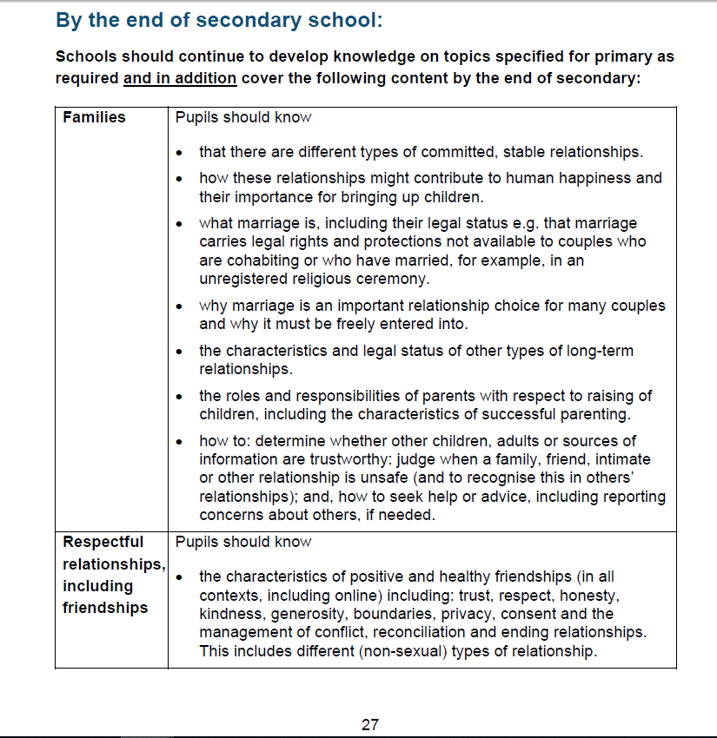

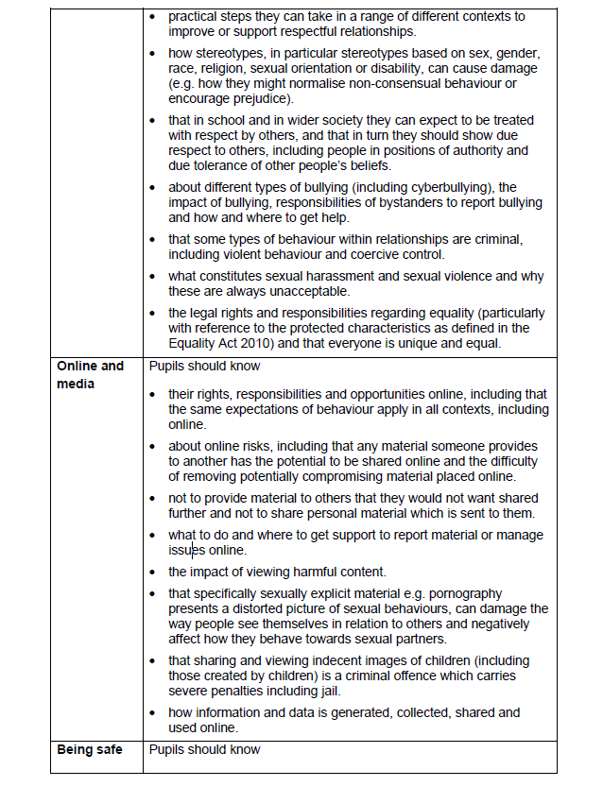

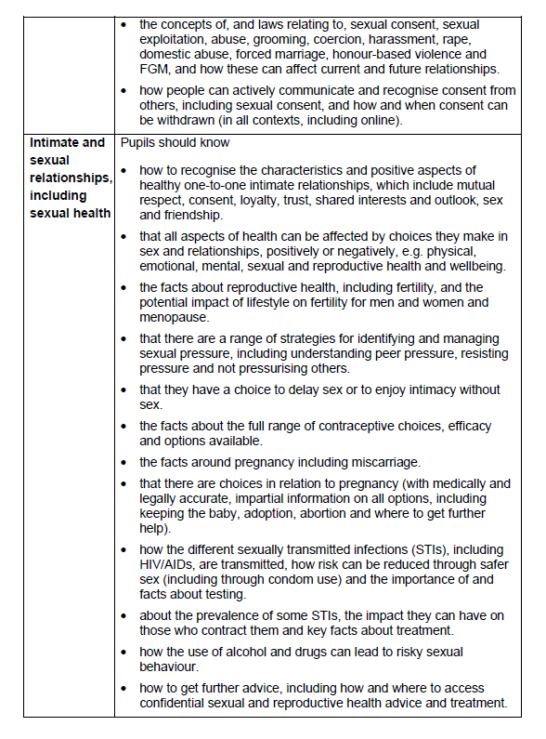

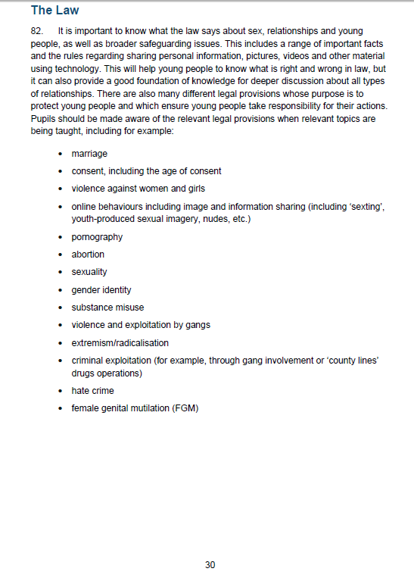

Further information can be found at:

https://www.gov.uk/government/news/relationships-education-relationships-and-sex-education-rse-and-health-education-faqs

https://assets.publishing.service.gov.uk/government/uploads/system/uploads/attachment_data/file/812594/RSE_secondary_schools_guide_for_parents.pdf

